# Tomasz Szumski

# BDAT1001

# [Assignment 1 - Encoding and Encryption](https://gc.blackboard.com/webapps/assignment/uploadAssignment?content_id=_5362430_1&course_id=_302880_1&group_id=&mode=view)

Screen Shot Converter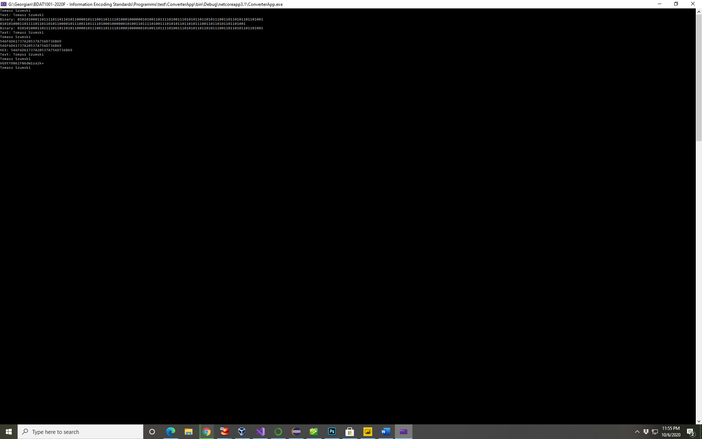

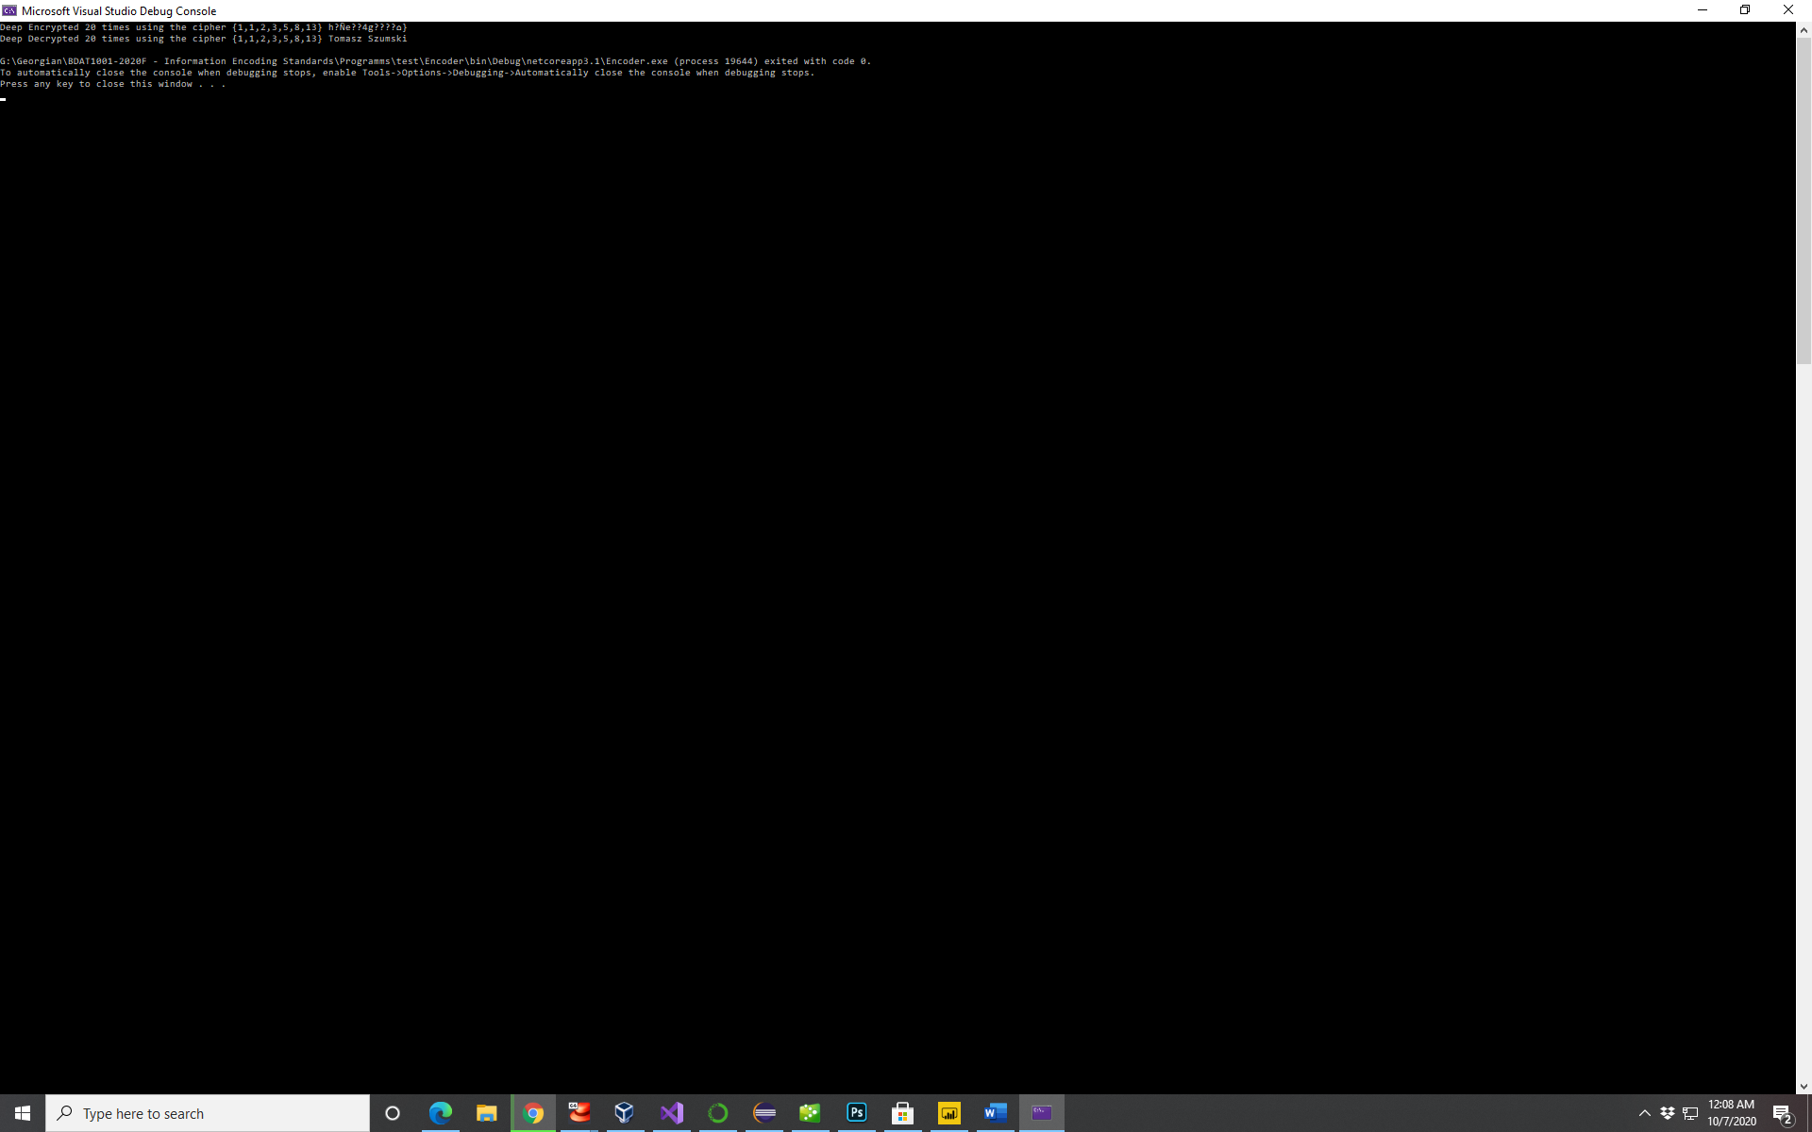Screen Shot Encryptor